[](https://www.c-sharpcorner.com/technologies/azure)

Push Pull Docker Image With Azure Container Registry

Docker Container Registry

Docker Container registry is a place where all the docker images you have built will be pushed (copied remotely) so that you can pull them anytime or in any system to create containers.

Most used registry is [https://hub.docker.com](https://hub.docker.com/) where all the open-source images are available for local deployment or can be used in production.

To pull images from hub.docker.com below cmd line is used.

docker pull postgres

BASIC

Copy

This is an example to pull Postgres latest image when default registry in local machine is hub.docker.com. The official image is available here - <https://hub.docker.com/_/postgres>

Azure Container Registry

Azure Container Registry also is the same as hub.docker.com but is provided by azure cloud. It has several features above the simple registry

The Azure Container registry can be private and can be used by only one team or users who have access. So, users with access can push and pull images.

It provides geo-replication so that images pushed in one datacenter in one region gets replicated in all the connected configured datacenters and gets deployed simultaneously to Kubernetes clusters in respective locations.

More can be read in the docs here - <https://azure.microsoft.com/en-us/services/container-registry/#overview>

Also images can be built as part of CI CD pipeline in Azure Pipelines and pushed to Azure Container registry, more read here - <https://docs.microsoft.com/en-us/azure/devops/pipelines/ecosystems/containers/acr-template?view=azure-devops>

The purpose of this article is to provide steps to create a Private Azure container registry and provide commands to push and pull images from newly created registry.

Steps to create registry

**Step 1**

Login to [https://portal.azure.com](https://portal.azure.com/)

**Step 2**

Search for Azure Container registry and click create as below,

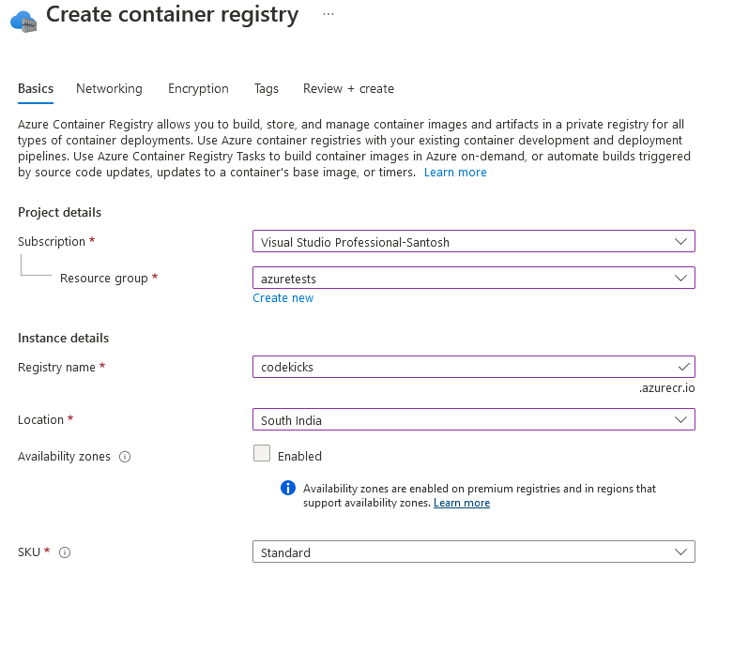

**Step 3**

Select a name for registry. This name cannot be changed later, so choose wisely

**Step 4**

Pricing varies with Basic, Standard and Premium.

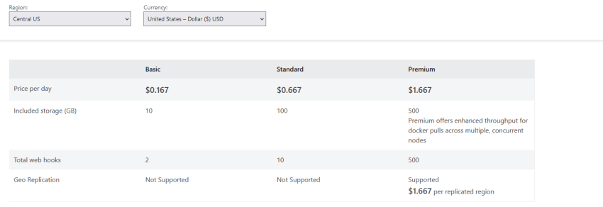

For testing, I will select basic

The registry will be available on public internet for basic tier. And encryption will be disabled.

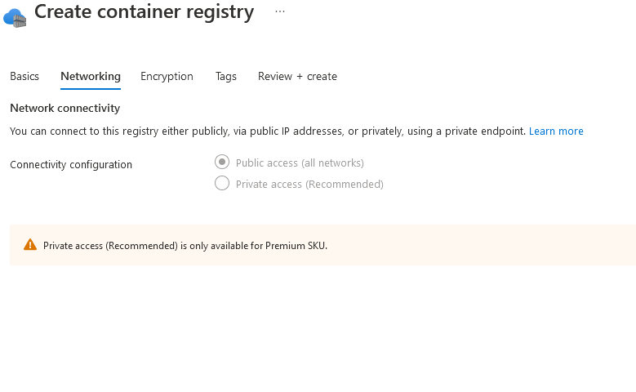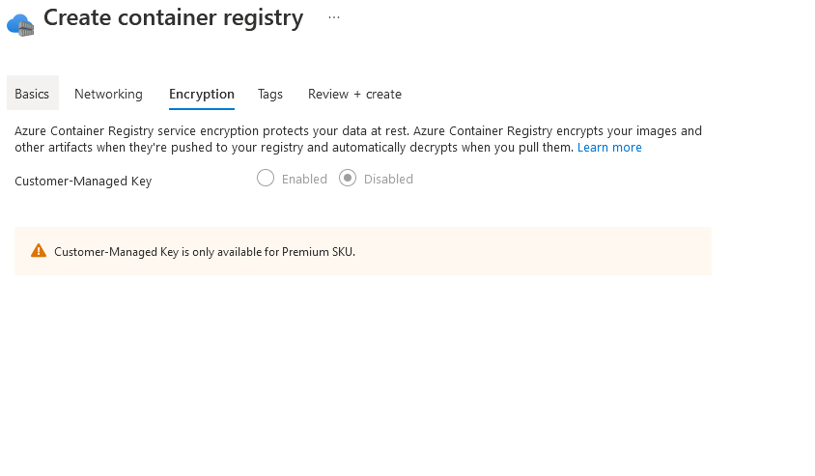

The summary is as shown below.

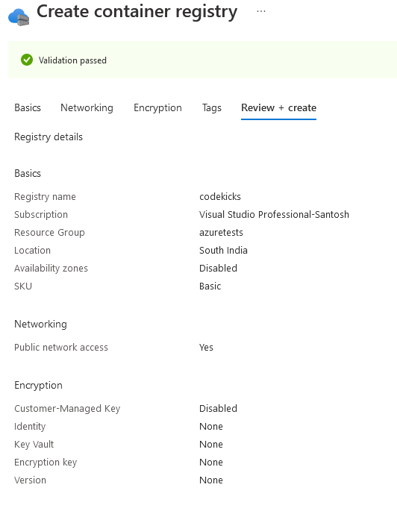

After the resource is created copy the access keys in the below tab.

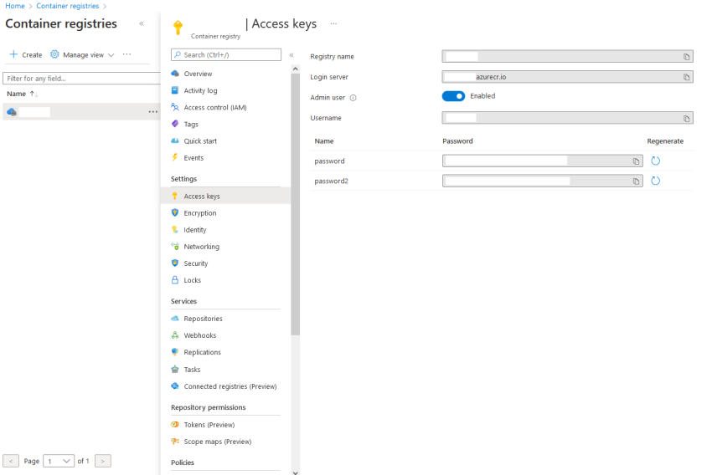

I have masked the name and keys in above image as I took snapshot from already used registry.

These login server details, and password is required every time you push/pull image to registry

Push Image to Azure Container Registry

1. First step before push or pull is to login.

docker login codekicks.azurecr.io -u username -p COPIEDKEYAZURECONTAINERREGISTRY

BASIC

Copy

1. Next is to build and tag the image with registry prefix

docker build . -f Dockerfile -t codekicks.azurecr.io/helloworld

BASIC

Copy

1. Final step is to push the above image

docker push codekicks.azurecr.io/helloworld

BASIC

Copy

Pull Image to Azure Container Registry

1. Login to registry

docker login codekicks.azurecr.io -u username -p COPIEDKEYAZURECONTAINERREGISTRY

BASIC

Copy

1. Pull the image with registry name prefix

docker pull codekicks.azurecr.io/helloworld

BASIC

Copy

Now you can use the local copy of the image to create containers.  
  
Note: To pull image directly onto docker-compose, kubernetes yml files, use appropriate logins. Usually in these scenarios, docker login is the first step before docker-compose up is called, so that images get pulled successfully

Conclusion

In this article, we have learned how to create Basic Azure Container registry which can be used by logged-in users and push and pull team built images, which inturn can be deployed to geo-replicated Kubernetes clusters.

**References**

1. <https://azure.microsoft.com/en-us/services/container-registry/#overview>
2. <https://docs.microsoft.com/en-us/azure/devops/pipelines/ecosystems/containers/acr-template?view=azure-devops>